RESOLUTION NO.__________

RE: CERTIFICATE OF APPROPRIATENESS UNDER THE
PROVISIONS OF THE ACT OF THE PENNSYLVANIA
LEGISLATURE 1961, JUNE 13, P.L. 282 (53
SECTION 8004) AND BETHLEHEM ORDINANCE NO.
3952 AS AMENDED.

The applicant proposes to replace awning at 428-436 Main St. (Moravian Book Shop).

NOW, THEREFORE, BE IT RESOLVED by the Council of the City of Bethlehem that a Certificate of Appropriateness is hereby granted for the proposal.

Sponsored by: (s)

(s)

ADOPTED BY COUNCIL THIS DAY OF

(s)
President of Council

ATTEST:

(s)
City Clerk

HISTORICAL & ARCHITECTURAL REVIEW BOARD

The applicant proposes to replace awning at 428-436 Main St.
(Moravian Book Shop)

APPLICATION #2:

Moravian College
1200 Main St.
Bethlehem, PA 18018

OWNER:

__________________________________________________________________________

The Board upon motion by Gen Marcon and seconded by Diana Hodgson adopted the proposal that City Council issue a Certificate of Appropriateness for the following:

- Replacement awning to be Taupe color “Sunbrella Fabric.

2. Lettering to be off-white on the drop panel at the front edge.

3. The edge to be straight not scalloped.

4. The motion was unanimously approved.

__________________________________________________________________________

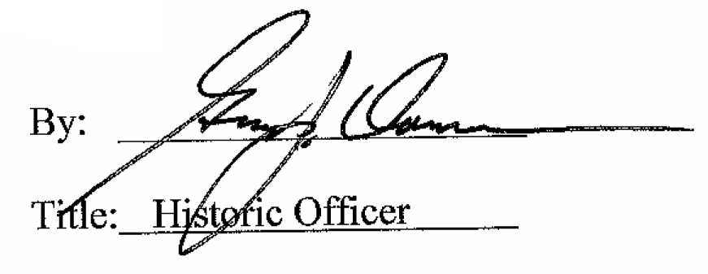

Date of Meeting: August 1, 2018

